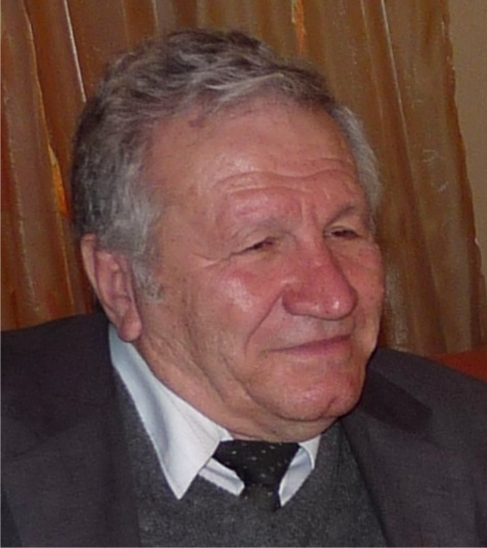

Prof. Dr. Traycho Penzov is graduated the speciality “Automatics and telemechanics” in Technical university – Sofia. From 1970 he is scientific co-worker in Central Scientific and Research Institute for Complex Automation. In 1981 T.Penzov defend a dissertation theses “Study and control of grinding aggregates with recycle in cement production”. He adapts and develops further the obtain results for the wet grinding of ores. In 1986 Dr. Penzov is chosen for “Senior scientific co-worker”, Head of laboratory. Dr. Penzov takes part as manager and leading specialist in over 90 developments, more of them are implemented. He has over 130 publications in local and foreign magazines, international symposiums and conferences in 17 countries. Nine of his developments are protected with author’s certificates for inventions and patents. Dr. Penzov is guest professor in Technical university and Mining and geological university as well as in foreign countries. Since 1991 he is Executive manager of innovative firm TRAPEN. For obtained high economic results Dr. Penzov is award with honorary diploma “Innovative enterprise 2005”, diplomas and silver medals from exhibition of inventions, innovations and new technologies, with special prize for electronics and automatic as well as with diploma for exclusive contribution for innovations at the development of automatically technologies.

